Creep Deformation and Rupture Behaviour of …..

X. Person^{1*}, Y. Person²

¹ Address X Person
² Address Y Person
*xperson@company.com

Summary
Austenitic stainless steels are known to harden significantly by the introduction of plastic strain, ……..

Key Words
Creep, austenitic stainless steel, cold working, creep deformation, creep ductility, boiler tube.

Introduction
Austenitic stainless steels are often used as high temperature structural components such as boiler tubes in thermal power plants because they are superior to ferritic steels …..

Material and experimental details
The material used was a hot-rolled TP304 stainless steel plate with a thickness of 50 mm, which has been subjected to solution heat treatment at 1050°C for 10 minutes (water cooling). Table 1 shows the chemical composition of the TP304 steel. Creep test data of the as-received material has been reported [8], and although ….

Microstructures of the as-received and the pre-strained TP304 stainless steel observed by SEM-EBSD are shown in Figure 1……

Table 1 Chemical compositions of tested type 304 stainless steel (wt%)
C | Si | Mn | P | S | Cr | Ni | Co | V | N
0.05 | 0.56 | 0.81 | 0.023 | 0.003 | 18.35 | 8.86 | 0.10 | 0.07 | 0.034

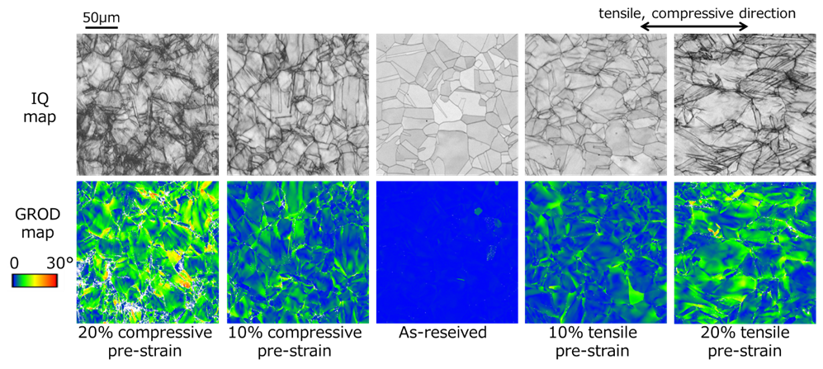
Figure 1 Microstructures of as-received and pre-strained materials observed by SEM-EBSD.

Results and discussion
Effect of pre-strain on creep rupture time and creep ductility
Relationship between stress and creep rupture time of as-received and pre-strained materials at 600°C is shown in Figure 2……….

Effect of pre-strain on creep deformation behaviour
Figures 4 and 5 show the creep deformation behaviour…..

Modelling of creep deformation
Relationship between stress and minimum creep strain rate at 600°C……

Modelling of creep rupture ductility
In this study, the ductility exhaustion approach expressed by the following equation is used as the creep damage evaluation method.

$d_{c}=\int_{0}^{t}{\left({{\dot{ε}}_{in}}/{ε_{f}}\right)dt}$ (6)

Application to bended part of boiler tube
Creep damage evaluation of the bended part of a boiler tube was…….

Conclusion
The effect of cold working on the creep properties of TP304 stainless steel were studied in this paper. ……….

The findings obtained are summarized below.
- The creep rupture life of the pre-strained material was longer than that of the as-received material at 600°C and high stress (250, 206 MPa), and the larger the amount of pre-strain, the longer the life.
- Under the …….

References
- ASME, Boiler and Pressure Vessel Code 2019 Section I-Rules for Construction Power Boilers, (2019).
[2]

Additional Notes to Authors.

Do you wish your paper to be submitted to Materials at High Temperatures………………Yes/No

Those papers accepted for inclusion in the MHT Journal will only appear in the conference proceedings as an abstract with reference to the full paper in the relevant edition of the Journal.

An abstracts book will be included within the delegate pack as below. You are invited to include a photo of the main author/presenter, to aid networking at the conference. If you prefer not to supply a photo we will happily include the abstract without a photo.
Any questions relating to paper/presentation and submission to paper please contact the Chair of the Scientific Committee Dr Augusto Di Gianfrancesco, a.digianfrancesco@libero.it

Any questions relating to the organisation of the conference, registration or administration please contact the Chair of the Organising Committee Dr Peter Barnard, peter.barnard@mpiuk.com

